Experiment No.03

Aim:
Implementation of OLAP operation in SQL Environment for the problem statement defined in first experiment.

.
Theory:

On-Line Analytical Processing (OLAP) is a category of software technology that enables an-
alysts, managers and executives to gain insight into data through fast, consistent, interactive
access in a wide variety of possible views of information that has been transformed from raw
data to reflect the real dimensionality of the enterprise as understood by the user.

OLAP Models:-(Detailed Description is required for following models)
- MOLAP
- ROLAP

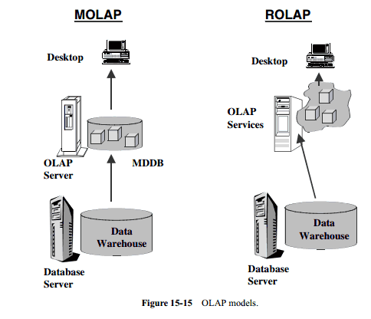

OLAP Operations:

- Roll up (drill-up): summarize data
  - by climbing up hierarchy or by dimension reduction
- Drill down (roll down): reverse of roll-up
  - from higher level summary to lower level summary or detailed data, or introducing new dimensions
- Slice and dice: project and select
- Pivot (rotate):
  - reorient the cube, visualization, 3D to series of 2D planes
- Other operations
  - drill across: involving (across) more than one fact table
  - drill through: through the bottom level of the cube to its back-end relational tables (using SQL)

Example:-

The below Description for Understanding not to write in journal

OLAP (Online Analytical Processing) operations are used for data analysis (summaries, trends, comparisons), while SQL is the tool we can use to implement them.

OLAP Operations in SQL
- ROLLUP – Creates subtotals and a grand total.
- CUBE – Creates subtotals for all possible combinations.
- GROUPING SETS – Allows custom grouping combinations.
- SLICE & DICE – Filtering specific rows/columns (using WHERE or SELECT).
- DRILL-DOWN / DRILL-UP – Move between levels of detail (using GROUP BY).

Example Dataset: Sales
Region | Product | Year | Sales
North | Laptop | 2024 | 50000
North | Mobile | 2024 | 30000
South | Laptop | 2024 | 20000
South | Mobile | 2024 | 15000

1. ROLLUP
Find total sales by Region and overall total.
SELECT Region, Product, SUM(Sales) AS Total_Sales
FROM Sales
GROUP BY ROLLUP (Region, Product);
This will give:
- Sales by (Region + Product)
- Sales by Region
- Grand Total

2. CUBE
Find sales by all combinations (Region, Product, and overall).
SELECT Region, Product, SUM(Sales) AS Total_Sales
FROM Sales
GROUP BY CUBE (Region, Product);
This gives:
- Sales by Region & Product
- Sales by Region
- Sales by Product
- Grand Total

3. GROUPING SETS
Custom totals (only the ones you want).
SELECT Region, Product, SUM(Sales) AS Total_Sales
FROM Sales
GROUP BY GROUPING SETS (
(Region, Product), -- Region + Product
(Region), -- Only Region
(Product), -- Only Product
() -- Grand Total
);

4. SLICE (filtering)
See sales only for Laptop.
SELECT Region, SUM(Sales) AS Laptop_Sales
FROM Sales
WHERE Product = 'Laptop'
GROUP BY Region;

5. DRILL-DOWN / DRILL-UP
- Drill-down (more detail):
SELECT Region, Product, SUM(Sales)
FROM Sales
GROUP BY Region, Product;
- Drill-up (summary level):
SELECT Region, SUM(Sales)
FROM Sales
GROUP BY Region;

- Use ROLLUP → subtotals + grand total
- Use CUBE → all possible summaries
- Use GROUPING SETS → custom combinations
- Use WHERE → slice
- Use GROUP BY hierarchy → drill-up / drill-down

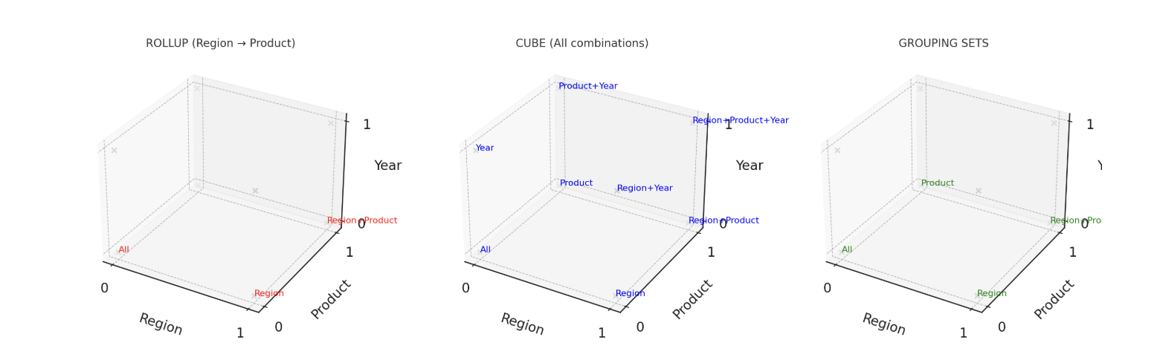

visual diagram of OLAP operations in SQL:
- ROLLUP (Region → Product) → Only hierarchical summaries (Region+Product → Region → All).
- CUBE → All possible combinations (Region, Product, Year, and all totals).
- GROUPING SETS → Only the combinations you specify (like Region, Product, All).

Example Data (Sales Table)
Region | Product | Sales
North | Laptop | 500
North | Mobile | 300
South | Laptop | 200
South | Mobile | 150

1️⃣ ROLLUP (Region → Product)
SQL:
SELECT Region, Product, SUM(Sales)
FROM Sales
GROUP BY ROLLUP (Region, Product);
Output:
Region | Product | Sales
North | Laptop | 500
North | Mobile | 300
North | NULL | 800
South | Laptop | 200
South | Mobile | 150
South | NULL | 350
NULL | NULL | 1150

2️ CUBE (Region, Product)
SQL:
SELECT Region, Product, SUM(Sales)
FROM Sales
GROUP BY CUBE (Region, Product);
Output:
Region | Product | Sales
North | Laptop | 500
North | Mobile | 300
North | NULL | 800
South | Laptop | 200
South | Mobile | 150
South | NULL | 350
NULL | Laptop | 700
NULL | Mobile | 450
NULL | NULL | 1150

3️. GROUPING SETS (Region, Product, All)
SQL:
SELECT Region, Product, SUM(Sales)
FROM Sales
GROUP BY GROUPING SETS (
(Region),
(Product),
()
);

Output:
Region | Product | Sales
North | NULL | 800
South | NULL | 350
NULL | Laptop | 700
NULL | Mobile | 450
NULL | NULL | 1150

- ROLLUP → Stepwise totals (Region → Product → All)
- CUBE → All possible totals (Region, Product, both, All)
- GROUPING SETS → Only the totals you choose

Sales Table example:
Region | Product | Sales
North | Laptop | 500
North | Mobile | 300
South | Laptop | 200
South | Mobile | 150

4️ SLICE (filtering data)
Example: Show sales only for Laptop
SELECT Region, SUM(Sales) AS Laptop_Sales
FROM Sales
WHERE Product = 'Laptop'
GROUP BY Region;
Output:
Region | Laptop_Sales
North | 500
South | 200

5️ DRILL-DOWN / DRILL-UP
- DRILL-DOWN = Go to more details
- DRILL-UP = Go to higher summary level

Drill-Down: Region → Product
SELECT Region, Product, SUM(Sales)
FROM Sales
GROUP BY Region, Product;
Output:
Region | Product | Sales
North | Laptop | 500
North | Mobile | 300
South | Laptop | 200
South | Mobile | 150

🔹 Drill-Up: Just Region
SELECT Region, SUM(Sales)
FROM Sales
GROUP BY Region;
Output:
Region | Sales
North | 800
South | 350

- SLICE = Filter → take only one layer of the cube (e.g., only Laptops).
- DRILL-DOWN = Go deeper into details (Region → Product).
- DRILL-UP = Go higher, summarize (Product → Region totals).

